Praneesh R V
CB.SC.U4CYS23036
SSE Lab Exercise 3 - Threat Modelling with OWASP Threat Dragon

Task 1 - Scope Definition
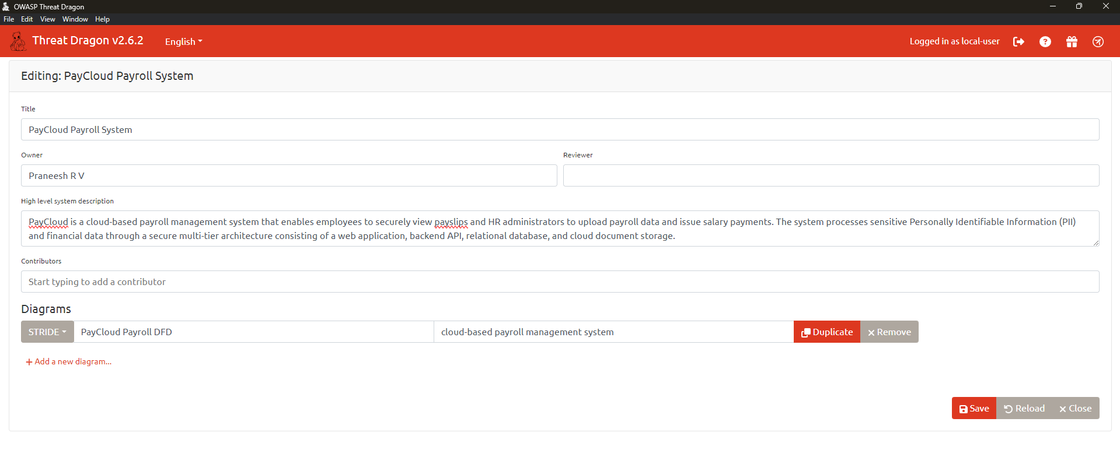
Task 2 - Architecture Mapping with DFD
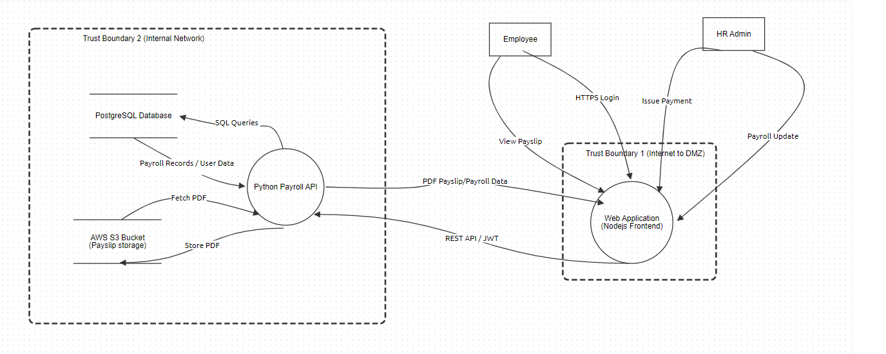
Task 3 - STRIDE Threat Identification
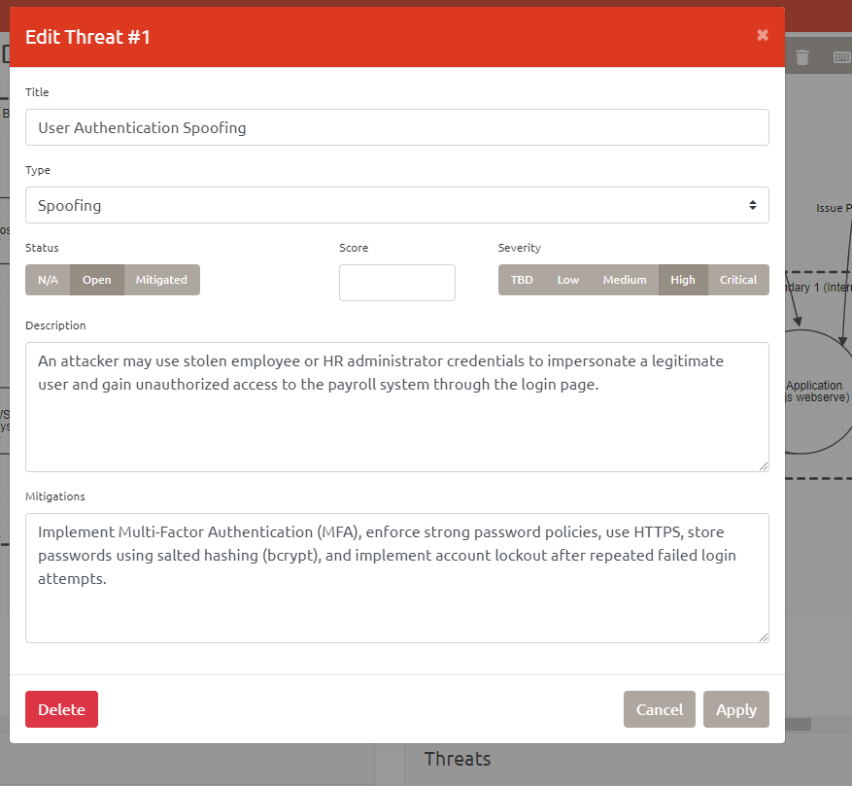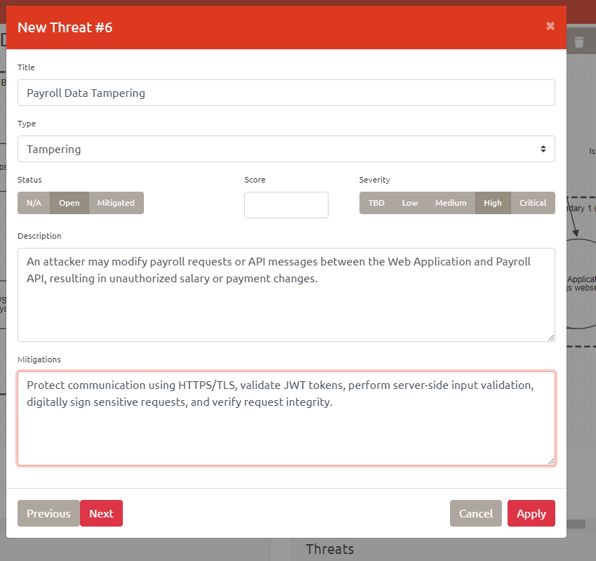
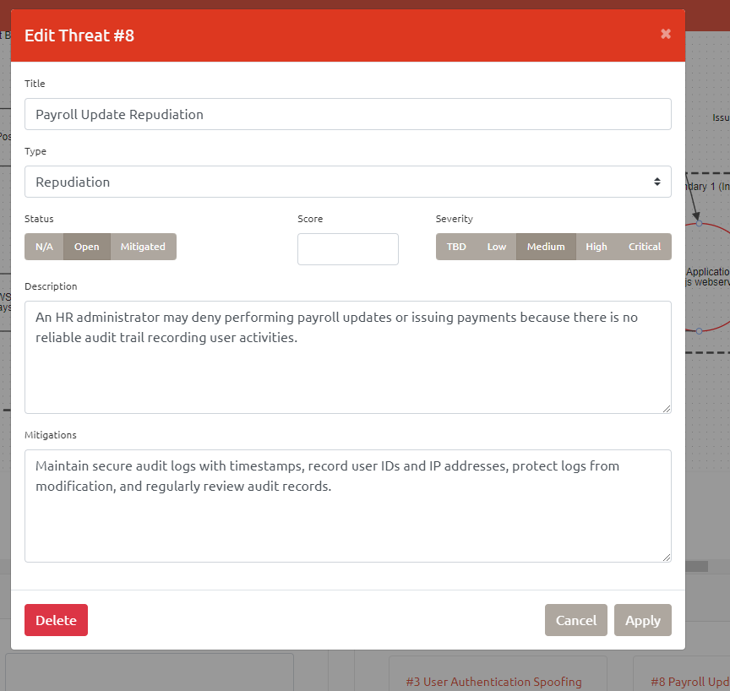
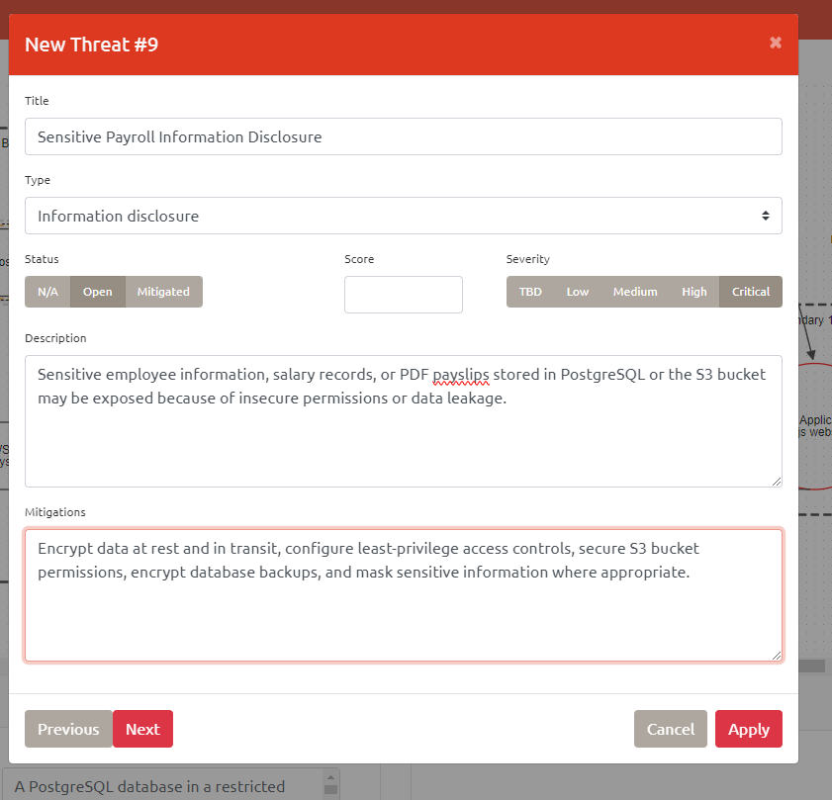

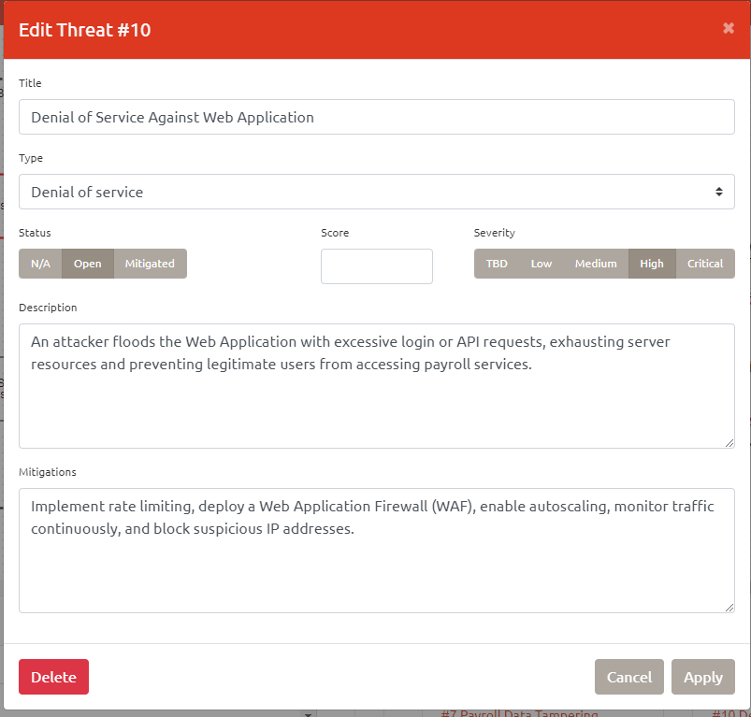
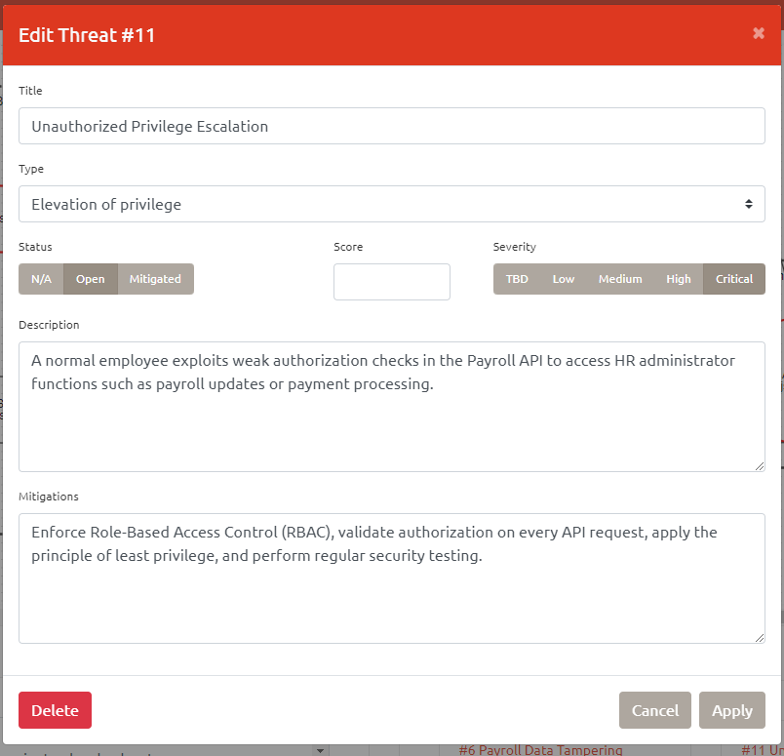

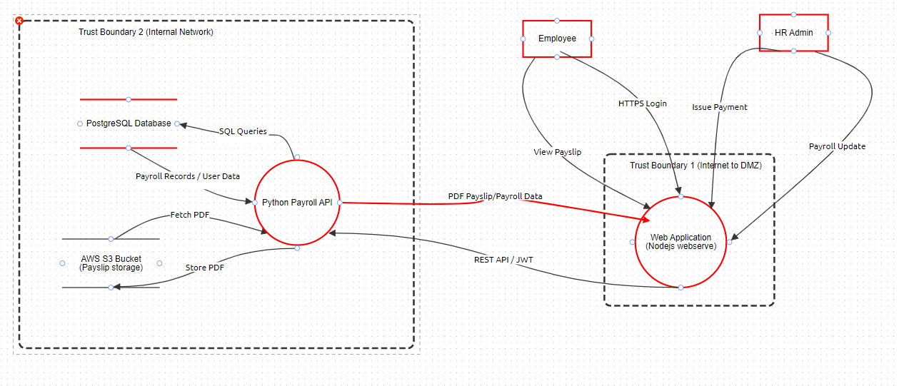

Spoofing
User Authentication Spoofing
An attacker may use stolen employee or HR administrator credentials to impersonate a legitimate user and gain unauthorized access to the payroll system through the login page.
Tampering
Payroll Data Tampering
An attacker may modify payroll requests or API messages between the Web Application and Payroll API, resulting in unauthorized salary or payment changes.

Repudiation
Payroll Update Repudiation
An HR administrator may deny performing payroll updates or issuing payments because there is no reliable audit trail recording user activities.

Information Disclosure
Sensitive Payroll Information Disclosure
Sensitive employee information, salary records, or PDF payslips stored in PostgreSQL or the S3 bucket may be exposed because of insecure permissions or data leakage.

Denial of Service
Denial of Service Against Web Application
An attacker floods the Web Application with excessive login or API requests, exhausting server resources and preventing legitimate users from accessing payroll services.

Elevation of Privilege
Unauthorized Privilege Escalation
A normal employee exploits weak authorization checks in the Payroll API to access HR administrator functions such as payroll updates or payment processing.

Task 4 - Documenting Mitigations

Mitigations
Spoofing - Implement Multi-Factor Authentication (MFA), enforce strong password policies, use HTTPS, store passwords using salted hashing (bcrypt), and implement account lockout after repeated failed login attempts.
Tampering - Protect communication using HTTPS/TLS, validate JWT tokens, perform server-side input validation, digitally sign sensitive requests, and verify request integrity.
Repudiation - Maintain secure audit logs with timestamps, record user IDs and IP addresses, protect logs from modification, and regularly review audit records.
Information Disclosure - Encrypt data at rest and in transit, configure least-privilege access controls, secure S3 bucket permissions, encrypt database backups, and mask sensitive information where appropriate.
Denial of Service - Implement rate limiting, deploy a Web Application Firewall (WAF), enable autoscaling, monitor traffic continuously, and block suspicious IP addresses.
Elevation of Privilege - Enforce Role-Based Access Control (RBAC), validate authorization on every API request, apply the principle of least privilege, and perform regular security testing.

